19.56: Solving Equations (19.22) and (19.24) to eliminate the volumes,
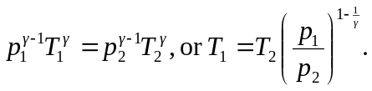
Using

